CHANGES HISTORY
PIC | Date | Remarks
BJM.MR | 2018.05.03 | Created
Ghaida | 2018.05.03

TOC
- Parameter Afa Charges
- Parameter Oms
- Parameter Bank Tdtype
- Parameter Bank Interest Accrued
- Parameter Bank Interest Type
- Parameter Bank Bank Type
- Parameter Afa Transaction Trx Link
- Parameter Afa Transaction Trx type
- Parameter Bank Td Status

Diagram ENTITY RELATIONSHIP

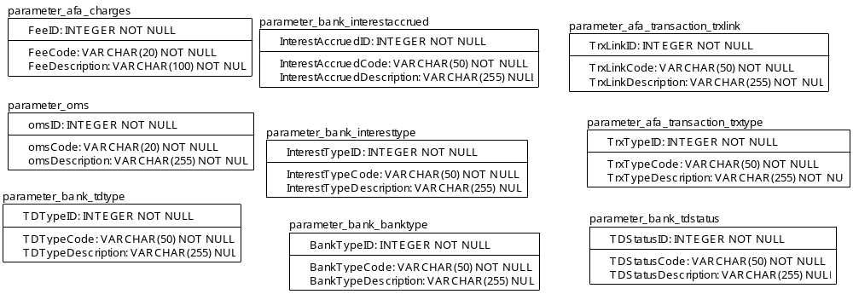

TABLE RELATIONSHIP
No | Table 1 | Table 2 | Type (1:1; 1:N; M:N) | Description

Name |  | Parameter_afa_charges
Objective
No | Column |  | Type | Rule  (PK, FK, Key, NN, Unik, Index) | Description
1. | FeeID |  | Integer | NN
2. | FeeCode |  | Varchar(20) | NN
3. | FeeDescription |  | Varchar(100) | NN

SAMPLE DATA
No | Column | Sample 1 | Sample 2 | Sample 3 | Sample 4
1. | FeeID | 1 | 2 | 3 | 4
2. | FeeCode | Management | Custodian | Audit | Commission
3. | FeeDescription | Management Fee | Custodian Fee | Audit Fee | Equities Broker Commission

Name |  | parameter_oms
Objective
No | Column |  | Type | Rule  (PK, FK, Key, NN, Unik, Index) | Description
1. | omsID |  | Integer | NN
2. | omsCode |  | Varchar(20) | NN
3. | omsDescription |  | Varchar(255) | NN

SAMPLE DATA
No | Column | Sample 1 | Sample 2 | Sample 3 | Sample 4
1. | omsID | 1
2. | omsCode | oms.simpi-pro
3. | omsDescription | OMTS SIMPI PRO

Name |  | parameter_bank_tdtype
Objective
No | Column |  | Type | Rule  (PK, FK, Key, NN, Unik, Index) | Description
1. | TDTypeID |  | Integer | NN
2. | TDTypeCode |  | Varchar(50) | NN
3. | TDTypeDescription |  | Varchar(255) | Null

SAMPLE DATA
No | Column | Sample 1 | Sample 2 | Sample 3 | Sample 4
1. | TDTypeID | 1 | 2 | 3
2. | TDTypeCode | BANK ACOUNT | ON CALL DEPOSIT | TIME DEPOSIT
3. | TDTypeDescription | Bank account, saving or checking | On call deposit < 1 Mo | Time deposit 1Mo, 3Mo, 6Mo, and 1Y

Name |  | parameter_bank_interestaccrued
Objective
No | Column |  | Type | Rule  (PK, FK, Key, NN, Unik, Index) | Description
1. | InterestAccruedID |  | Integer | NN
2. | InterestAccruedCode |  | Varchar(50) | NN
3. | InterestAccruedDescription |  | Varchar(255) | Null

SAMPLE DATA
No | Column | Sample 1 | Sample 2 | Sample 3 | Sample 4
1. | InterestAccruedID | 1 | 2 | 3
2. | InterestAccruedCode | NONE | DAILY | TIME DEPOSIT
3. | InterestAccruedDescription | No interest accrued | Interest accrued on daily basis | Time deposit 1Mo, 3Mo, 6Mo, and 1Y

Name |  | parameter_bank_interesttype
Objective
No | Column |  | Type | Rule  (PK, FK, Key, NN, Unik, Index) | Description
1. | InterestTypeID |  | Integer | NN
2. | InterestTypeCode |  | Varchar(50) | NN
3. | InterestTypeDescription |  | Varchar(255) | Null

SAMPLE DATA
No | Column | Sample 1 | Sample 2 | Sample 3 | Sample 4
1. | InterestTypeID | 1 | 2 | 3
2. | InterestTypeCode | NONE | MONTHLY | MATURITY
3. | InterestTypeDescription | No bank interest | bank interest paid on monthly basis | bank interest paid at maturity

Name |  | parameter_bank_banktype
Objective
No | Column |  | Type | Rule  (PK, FK, Key, NN, Unik, Index) | Description
1. | BankTypeID |  | Integer | NN
2. | BankTypeCode |  | Varchar(50) | NN
3. | BankTypeDescription |  | Varchar(255) | Null

SAMPLE DATA
No | Column | Sample 1 | Sample 2 | Sample 3 | Sample 4
1. | BankTypeID | 1 | 2
2. | BankTypeCode | BANK ACCOUNT | BANK DEPOSIT
3. | BankTypeDescription | Bank Account | Time deposit: on call, 1Mo, 3Mo, 6Mo, 1Y

Name |  | parameter_afa_transaction_trxlink
Objective
No | Column |  | Type | Rule  (PK, FK, Key, NN, Unik, Index) | Description
1. | TrxLinkID |  | Integer | NN
2. | TrxLinkCode |  | Varchar(50) | NN
3. | TrxLinkDescription |  | Varchar(255) | NN

SAMPLE DATA
No | Column | Sample 1 | Sample 2 | Sample 3 | Sample 4
1. | TrxLinkID | 0 | 1 | 3 | 4
2. | TrxLinkCode | TD BREAK REVERSAL | BANK TRANSFER IN | BANK TRANSFER OUT | BANK TRANSFER OUT REVERSAL
3. | TrxLinkDescription

Name |  | parameter_afa_transaction_trxtype
Objective
No | Column |  | Type | Rule  (PK, FK, Key, NN, Unik, Index) | Description
1. | TrxTypeID |  | Integer | NN
2. | TrxTypeCode |  | Varchar(50) | NN
3. | TrxTypeDescription |  | Varchar(255) | NN

SAMPLE DATA
No | Column | Sample 1 | Sample 2 | Sample 3 | Sample 4
1. | TrxTypeID | 1 | 2 | 3 | 4
2. | TrxTypeCode | EQ BUY | EQ SELL | FI BUY | FI SELL
3. | TrxTypeDescription | Equities Purchase | Equities Sale | Fixed Income Purchase | Fixed Income Sale

Name |  | parameter_bank_tdstatus
Objective
No | Column |  | Type | Rule  (PK, FK, Key, NN, Unik, Index) | Description
1. | TDStatusID |  | Integer | NN
2. | TDStatusCode |  | Varchar(50) | NN
3. | TDStatusDescription |  | Varchar(255) | Null

SAMPLE DATA
No | Column | Sample 1 | Sample 2 | Sample 3 | Sample 4
1. | TDStatusID | 1 | 2 | 3 | 4
2. | TDStatusCode | PLACEMENT | BREAK | MATURE | REVERSAL
3. | TDStatusDescription | Transaction deposit placement | Transaction deposit break | Transaction deposit maturity | Transaction deposit reversal
i

Name |  | pm_model_portfolio
Objective
No | Column |  | Type | Rule  (PK, FK, Key, NN, Unik, Index) | Description
1. | pmID |  | BIGInteger | FK
2. | MemberID |  | Integer | FK

SAMPLE DATA
No | Column | Sample 1 | Sample 2 | Sample 3 | Sample 4
1. | pmID
2. | MemberID

